**23CSE101**

**OBJECT ORIENTED PROGRAMMING**

**LAB MANUAL**



**Department of Computer Science Engineering**

**Amrita School of Computing**

**Amrita Vishwa Vidyapeetham, Amaravati Campus**

**Verified By Name: K .BHAVAGNYA**

**Roll No: AV.SC.U4CSE24209**

**WEEK-01**

**PROGRAM-1:**

**AIM:-** Download and install java software.

**PROCEDURE:-**

**1.Download JDK21:**

i. Open the web browser and go to Oracle JDK Downloads page.

ii. Scroll down to the Java SE Development Kit 21 section.

iii.Select` the Windows x64 Installer version.

iv. Click on Download, then Wait for the download to complete**.**

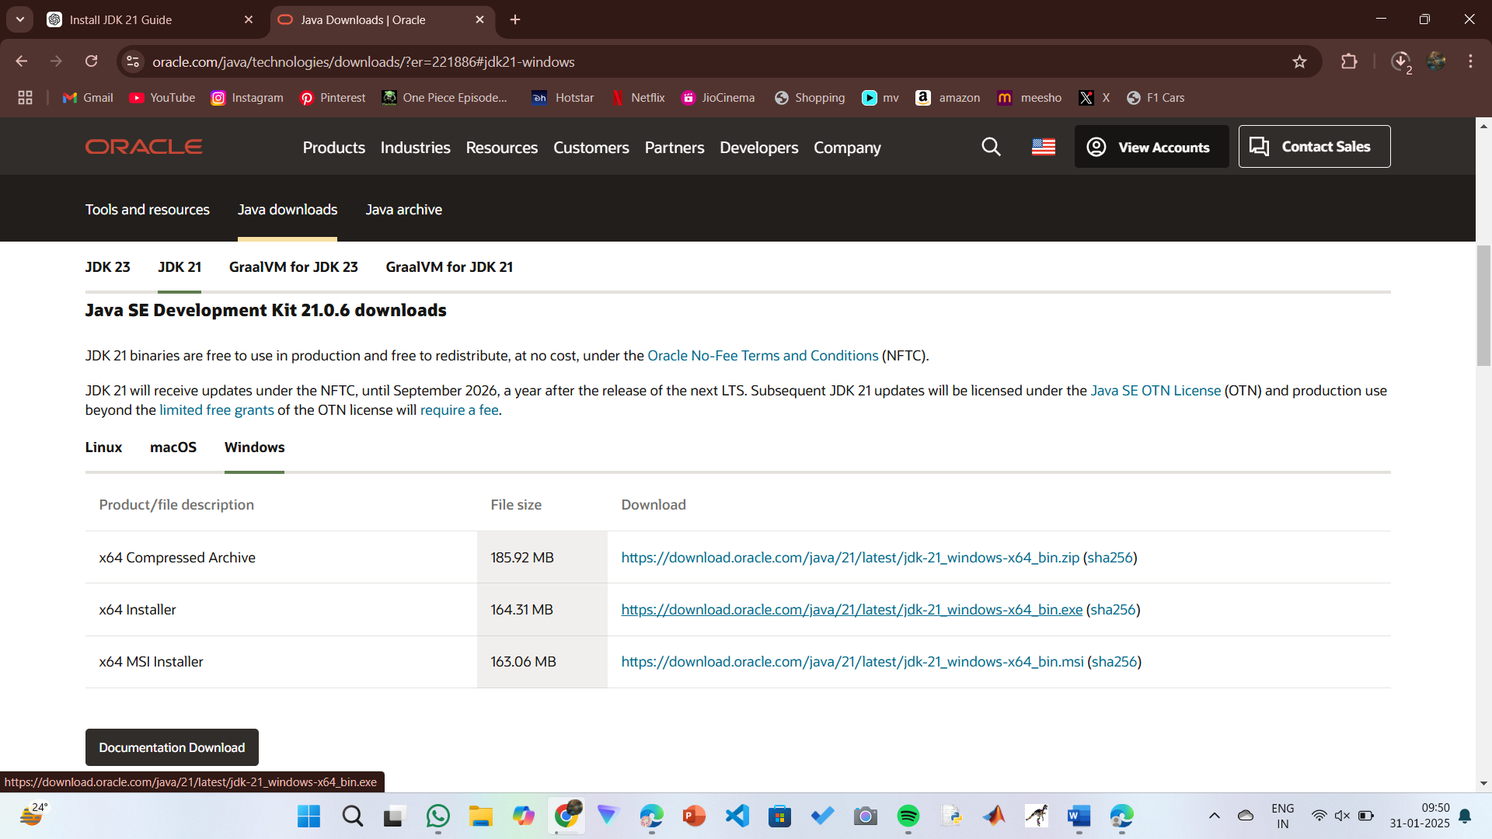

**Step 2:** **Installation of JDK 21:-**

1. Locate the downloaded jdk-21_windows-x64_bin.exe file.
2. Double-click to launch the installer.
3. Click Next on the setup wizard.
4. Choose the installation path (default is C:\Program Files\Java\jdk-21).
5. Click Next, then click Install.
6. Wait for the installation to complete.

vii. Click Close once the installation is finished.

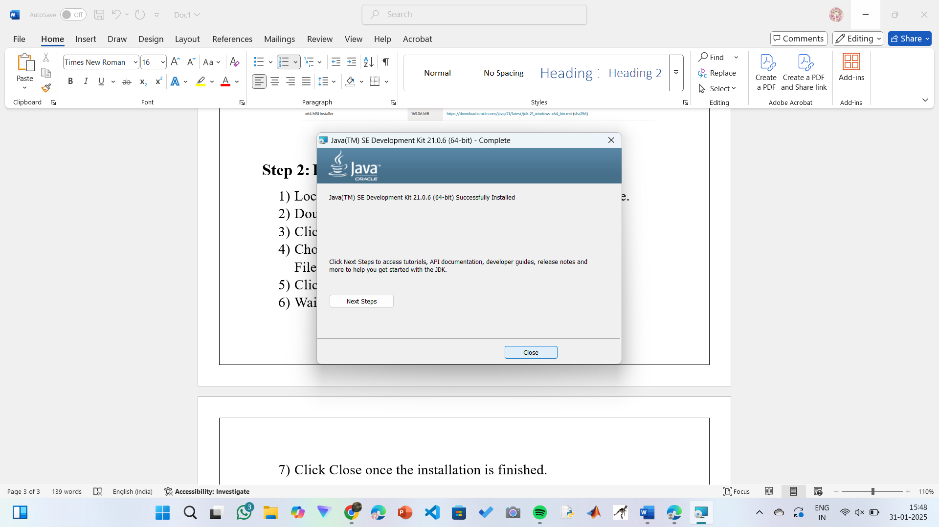

**Step 3: Setting up the path:-**

i. Go to “Windows C” Drive in This PC.

ii. Choose Program Files, select Java, then JDK 21, then select Bin.

iii. Select and copy the path at the address bar.

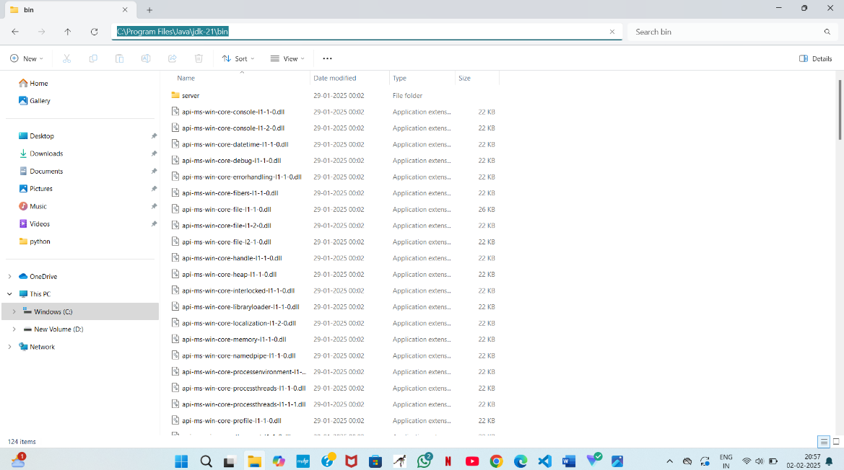

**Step 4: Open System Properties:-**

i.Press Windows + R, type sysdm.cpl , and click Ok-

ii.The System Properties window will open.

iii.Navigate to the Advanced tab.

iv.Click on Environment Variables at the bottom.

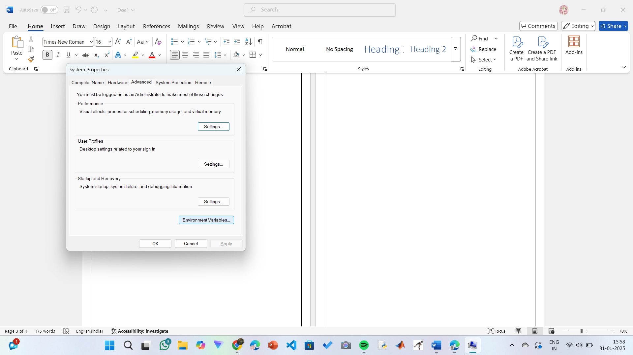

**Step 5: Setting up of JAVA_HOME:-**

i.Under System Variables, click New.

ii. Set the Variable name as JAVA_HOME.

iii. Set Variable value as C:\Program Files\Java\jdk-21 (or your installation path).

iv. Click on OK.

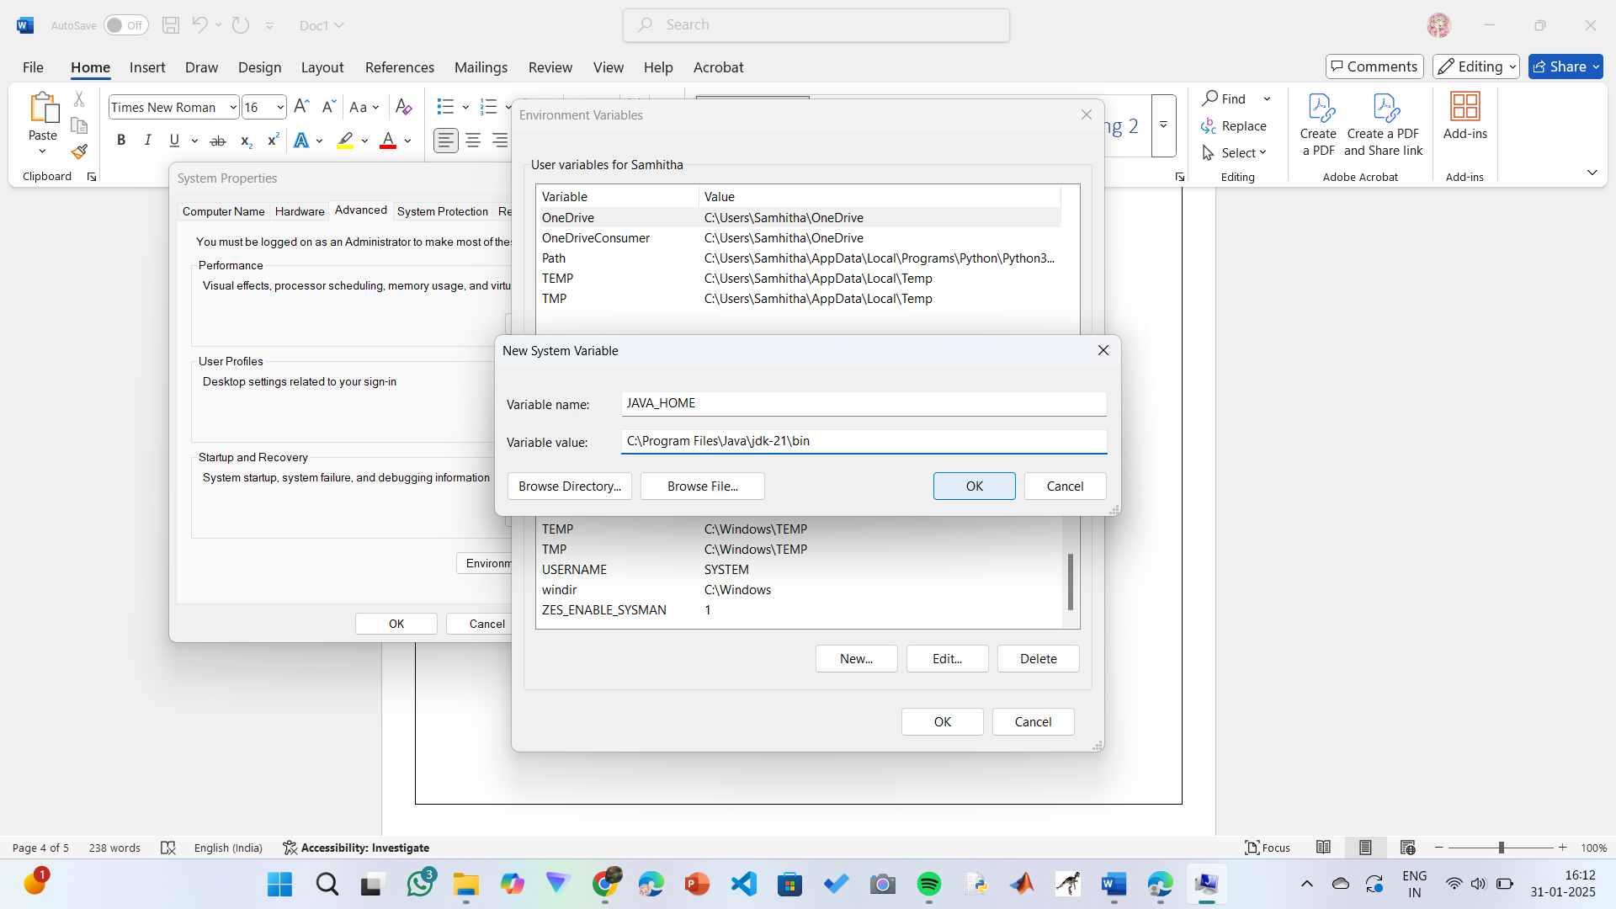

**Step 6: Update the PATH Variable:-**

i.In System Variables, find Path and click Edit.

ii.Click New and add: C:\Program Files\Java\jdk-21\bin

iii.Click OK to save.

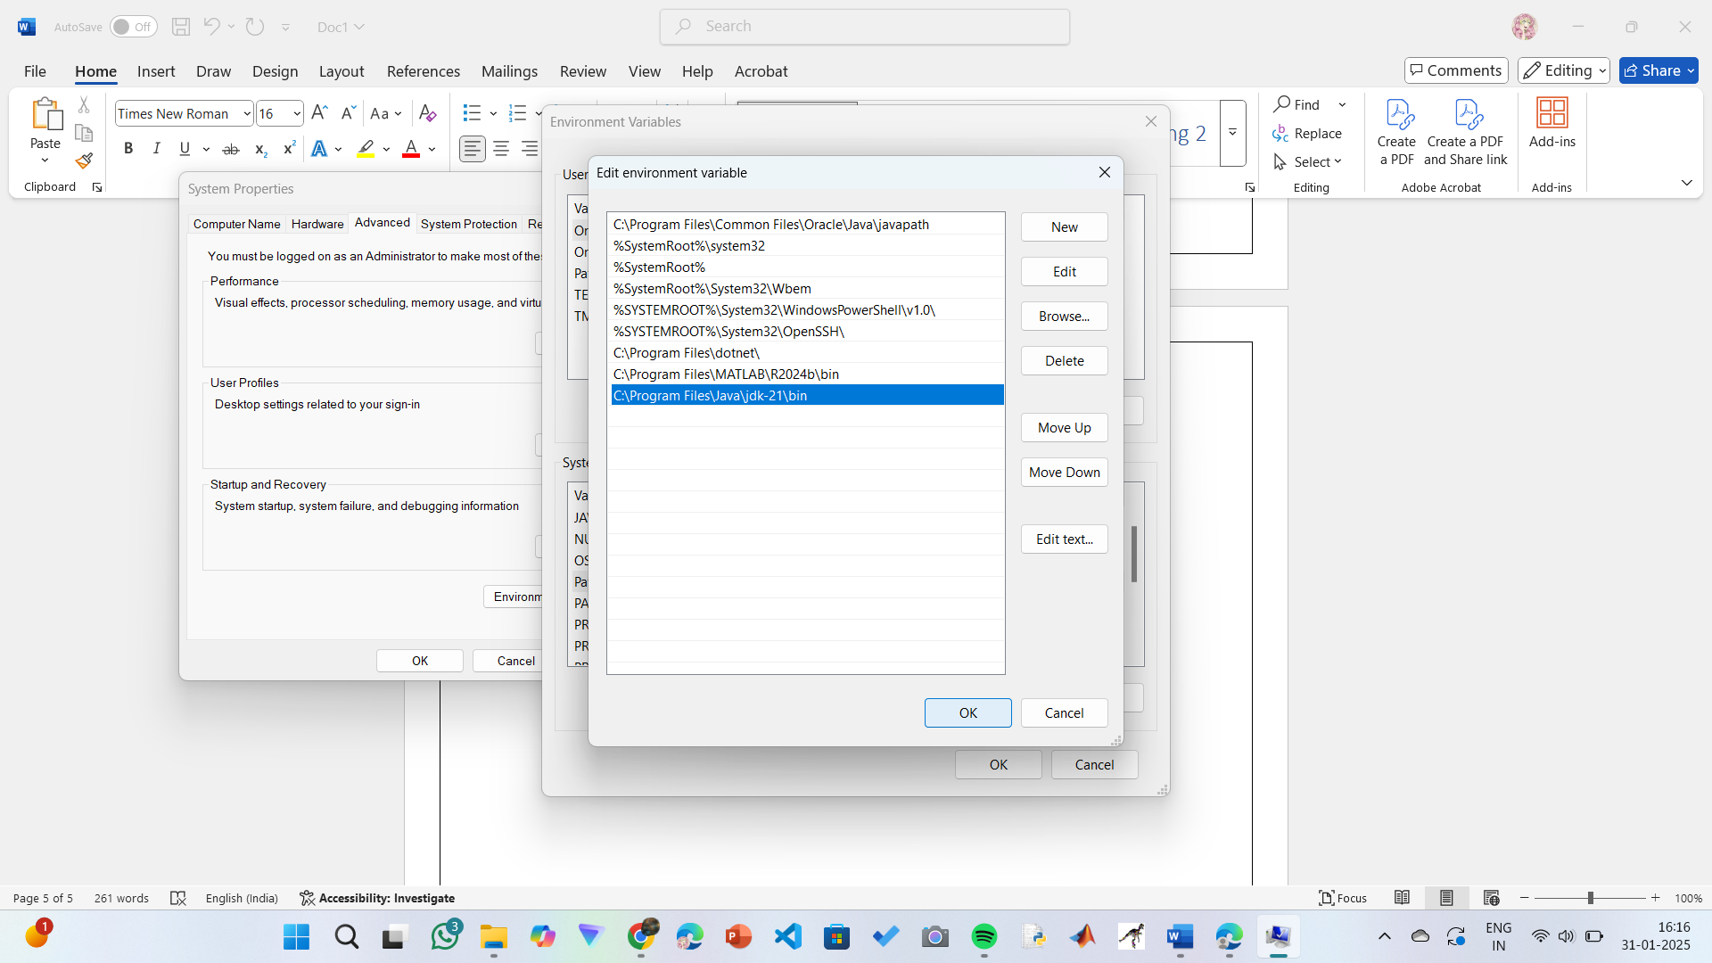

**Step 7:Verify Installation1:-**

i.Open Command Prompt.

ii.Type the following command: **java --version** and press Enter.

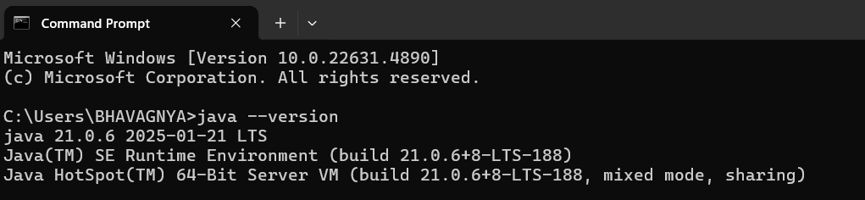

iii.To check the java compiler type: **javac –version.**

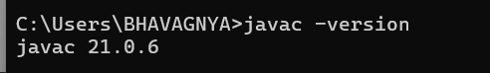

**PROGRAM-2:**

**AIM:** Write a Java program to print the message “Welcome to Java Programming.”

**CODE:**

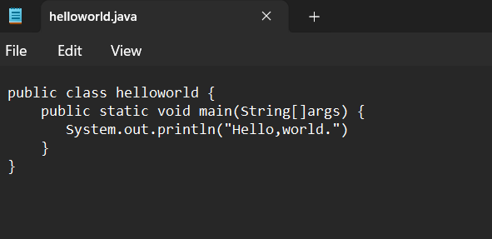**OUTPUT:-**

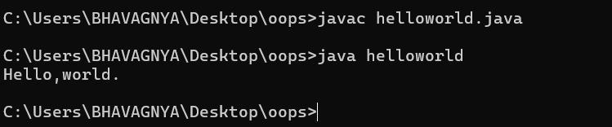

**ERRORS:-**

No Errors found.

**PROGRAM-3:**

**AIM:** Write a Java Program that prints Name, Roll No, Section of a student.

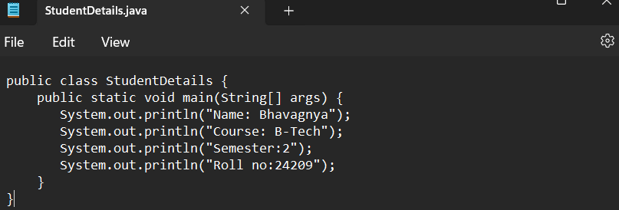

**OUTPUT:-**

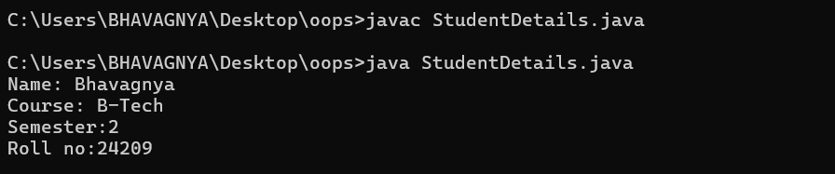

ERROR TABLE:

|  |  |
| --- | --- |
| **ERROR IN CODE** | **ERROR RECTIFICATION** |
| 1. ; is missing | 1. code is rectified by keeping a (;) in every place where it is missing. |

**WEEK-2:**

**PROGRAM-1:**

AIM: Write a java program to find the simple interest where all the inputs are given by the user.

CODE:

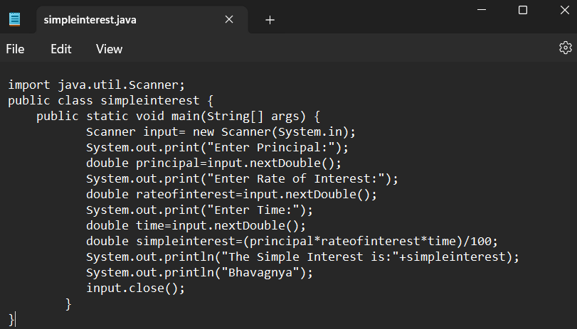

**OUTPUT:-**

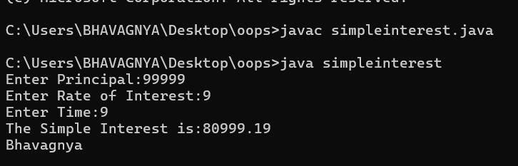

**ERROR TABLE:**

|  |  |  |
| --- | --- | --- |
|  | ERROR | ERROR RECTIFICATION |
| 1) | ; is expected after input.close() | Corrected by writing a ; after input.close() |
| 2) | Error in the line double principal=input.next.double(); | Corrected by removing “. “after the next. |

**PROGRAM-2:**

**AIM**: Write a java program to find the factorial of a number where all the inputs are given by the user.

**CODE:**

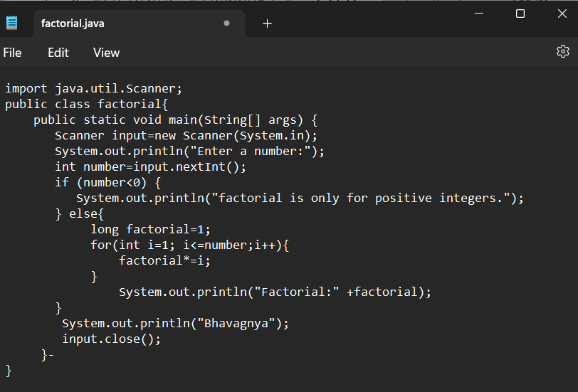

**OUTPUT:**

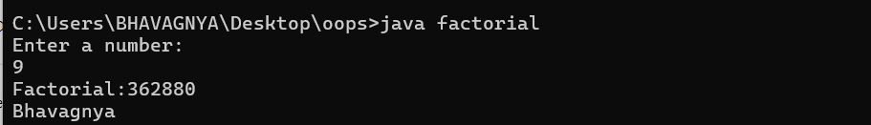

**ERROR TABLE:**

|  |  |  |
| --- | --- | --- |
|  | ERROR | ERROR RECTIFICATION |
| 1) | writing small “S” in place of ”S” in system.out.println() | code is rectified by keeping capital “S” |
| 2) | “ is missed in the print statement | Corrected by keeping “ in the end of print statement. |

**PROGRAM-3:**

**AIM**: Write a java program to convert the temperature from Celsius to Fahrenheit and Celsius to Fahrenheit.

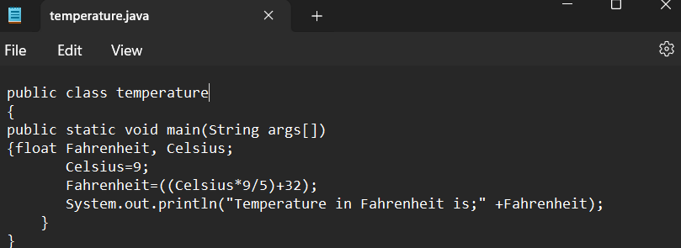

**OUTPUT:-**

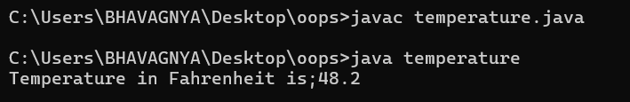

**CODE2:**

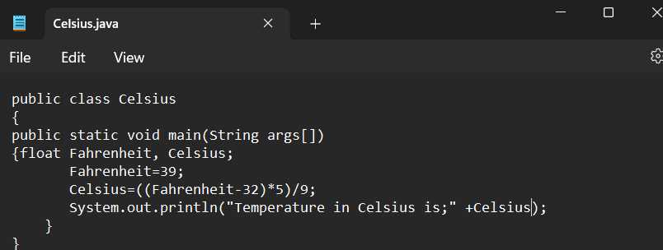

**OUTPUT:**

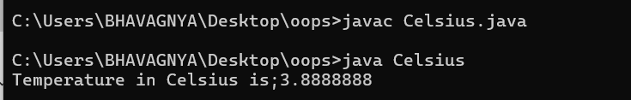

**ERROR TABLE:**

|  |  |  |
| --- | --- | --- |
| S.NO | ERROR | ERROR RECTIFICATION |
| 1. | Logical error  Missed * after Celsius in code 1 | Corrected by keeping a * operator in the appropriate place |

**PROGRAM – 4:**

AIM: Write a java program to find the Fibonacci series of a given number where all the inputs are taken from the user.

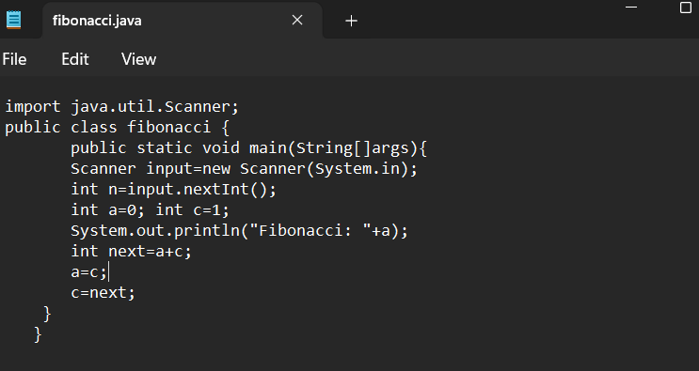

**OUTPUT:**

|  |  |  |
| --- | --- | --- |
| S.NO | ERROR | ERROR RECTIFICATION |
| 1. | Expected an ; after line 4 | Corrected by keeping an ; after the line |

PROGRAM-5:

AIM: Write a java program to find the area of a rectangle where the inputs are given by the user.

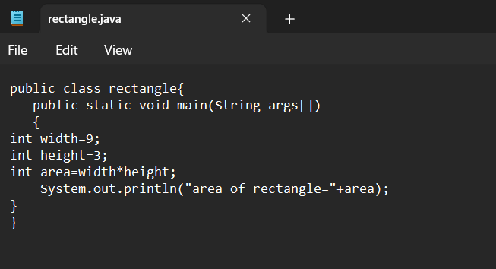

OUTPUT:

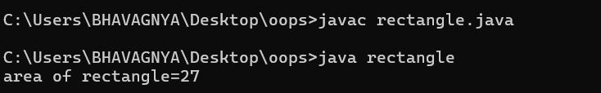

|  |  |  |
| --- | --- | --- |
|  | ERROR | ERROR RECTIFICATION |
| 1. | “ “ expected in the print statement | Corrected by closing the print statement with “ |

**PROGRAM-6**

AIM: Write a java program to find the area of a triangle where the inputs are given by the user.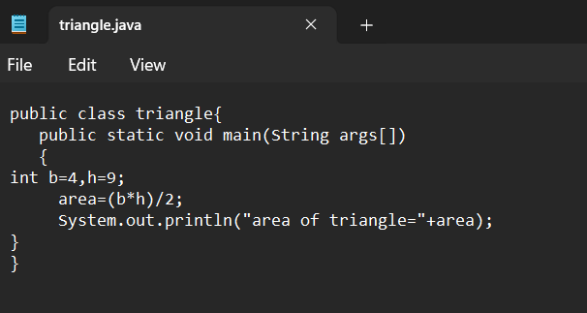

OUTPUT:

**ERROR TABLE:**

NO ERRORS

**WEEK-03**

**PROGRAM-1:**

**AIM:**

|  |
| --- |
| Bank account |
| -balance:double |
| +bank account initial balance:double  +deposit amount:double  +withdrawal:double  +getbalance():double |

**CODE:**

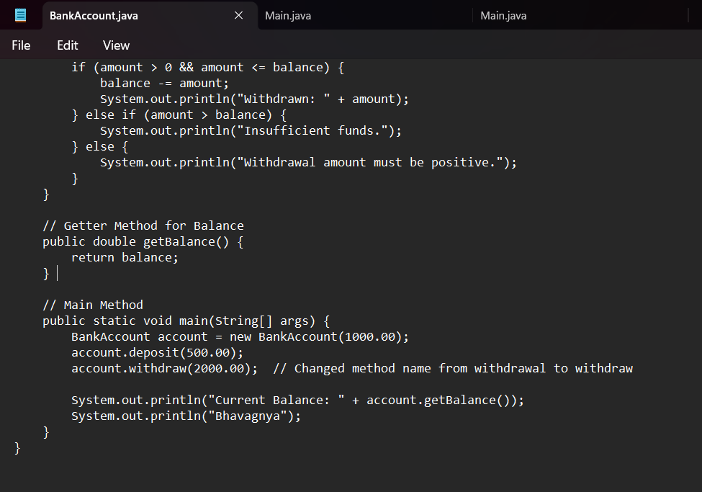

**OUTPUT:**

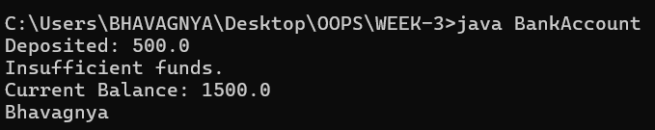

**ERROR TABLE:**

|  |  |  |
| --- | --- | --- |
|  | ERROR | ERROR RECTIFICATION |
| 1. | writing small “S” in place of ”S” in system.out.println() | code is rectified by keeping capital “S” |

**PROGRAM-2:**

**AIM:** Create a class car. Create four attributes named car_color, car_brand, fuel_type, mileage. Create three methods start() stop() service().Create 3 objects named car1 car2 car3.

|  |
| --- |
| car |
| +car color:string  +car brand:sstring  -fuel type:string  -mileage:double |
| +start():void  +stop():void  -service():void  +car1():void  +car2():void  +car3():void |

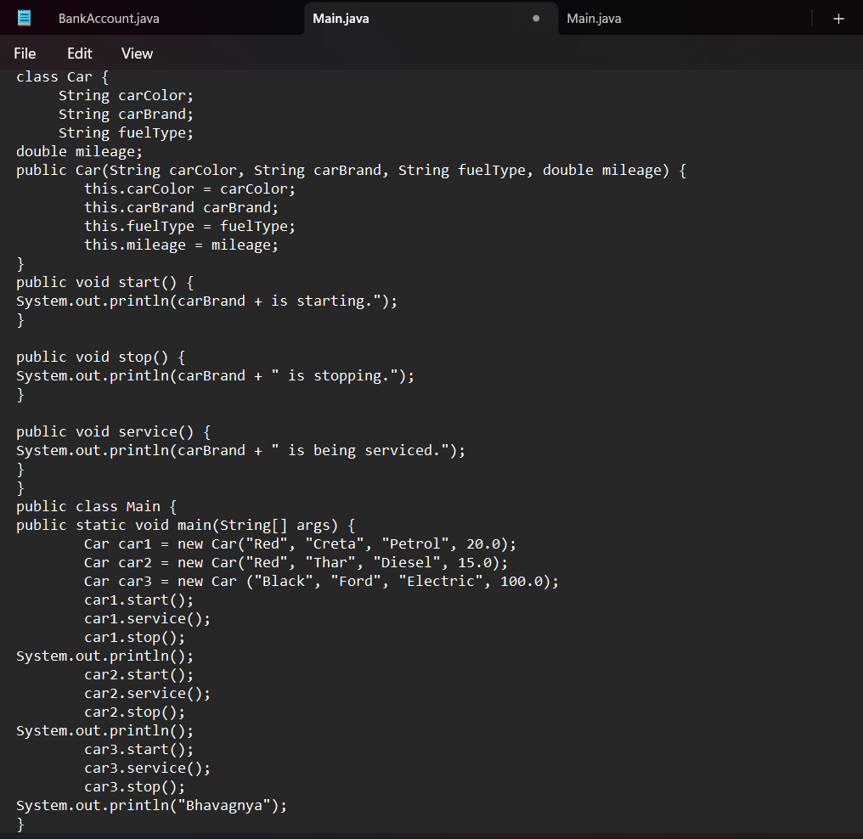

**OUTPUT:**

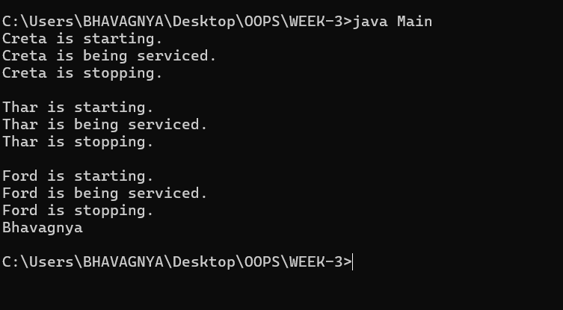

**ERROR TABLE:**

|  |  |  |
| --- | --- | --- |
|  | ERROR | ERROR RECTIFICATION |
| 1. | writing small “S” in place of ”S” in system.out.println() | code is rectified by keeping capital “S” |

**WEEK-04**

**PROGRAM-1:**

**AIM: Write a java program with class named book. The class should contain various attributes such as title, author, year of publication. It should also contain a constructor with parameters which initializes title, author, Year of publication. Create a method which displays the details of book. Display the details of two books.**

**CODE:**

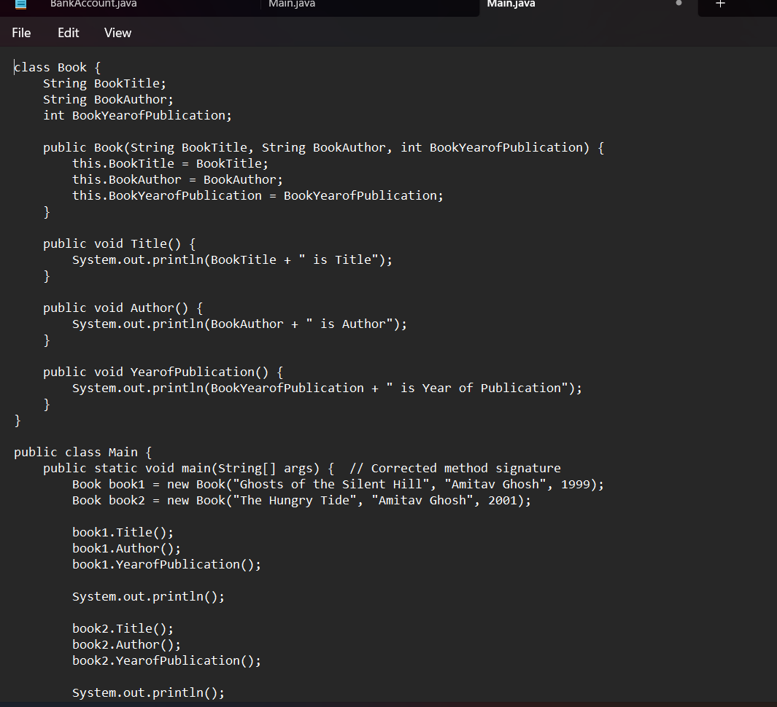

**OUTPUT:**

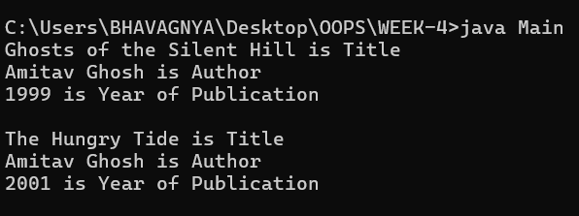

**ERROR TABLE:**

|  |  |  |
| --- | --- | --- |
|  | ERROR | ERROR RECTIFICATION |
| **1.** | “ is missed in the print statement | Corrected by keeping “ in the end of print statement. |

**PROGRAM-2:**

**AIM: Create a java program with class name Myclass with a starting variable count of int type, initialized to zero and a constant variable “pi” of type double initialized to 3.14 as attributes of that class. Define a constructor for “myclass” that increments the count variable each time an object of myclass is created. Finally print the final values of count and pi variables. Create three objects.**

**CODE:**

**/**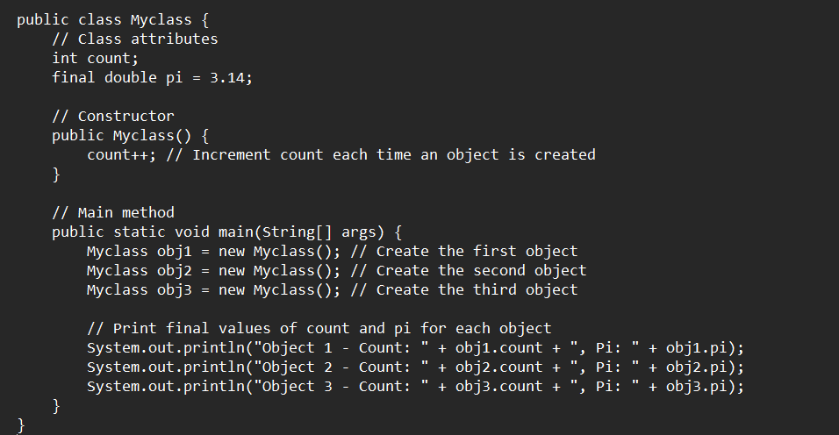

**OUTPUT:**

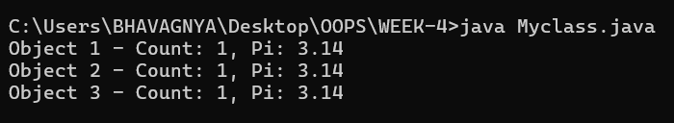

**ERROR TABLE:**

|  |  |  |
| --- | --- | --- |
|  | ERROR | ERROR RECTIFICATION |
| 1. | Missed; after creating object | Corrected by placing; after every object |
| 2. | } closing is missing | Corrected by closing the code with } |

**WEEK-05**

**PROGRAM-1:**

**AIM**: Create a calculator using the operations including addition, subtraction, multiplication and division using Multilevel Inheritance and display the desired output**.**

**CLASS DIAGRAM:**

**MULTILEVEL INHERITANNCE**

|  |
| --- |
| Calculator |
| - num1: int  - num2: int |
| + add(): int  + subtract(): int |

|  |
| --- |
| Calculator1 |
| - num1: int  - num2: int |
| + multiply(): int |

|  |
| --- |
| Calculator2 |
| - num1: int  - num2: int |
| + divide(): int |

**CODE:**

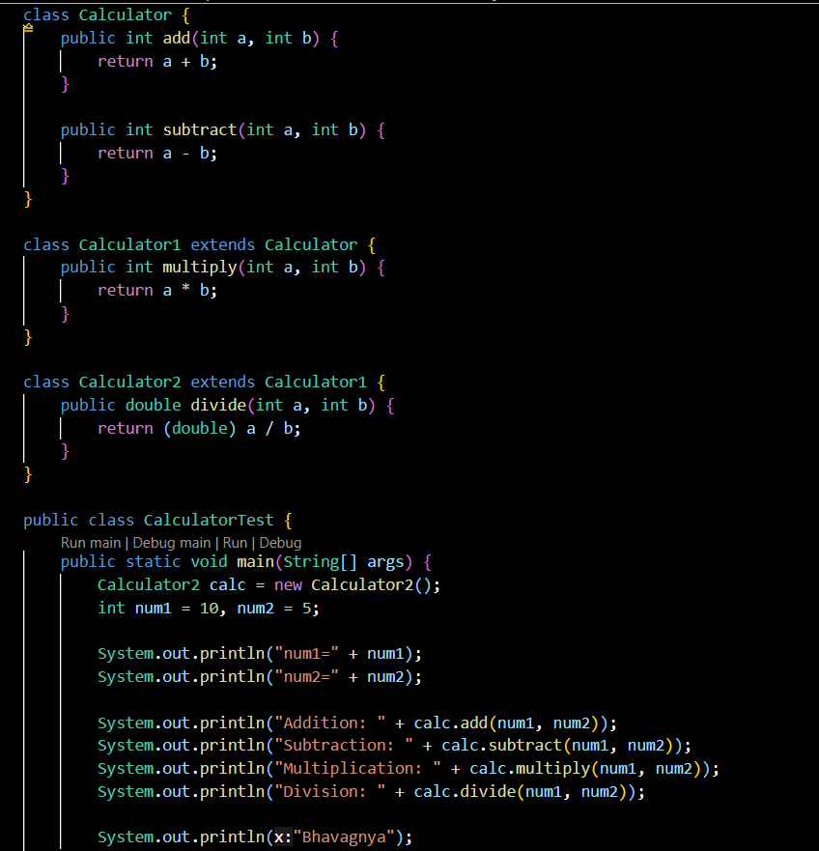

**OUTPUT:**

**POSITIVE CASE:**

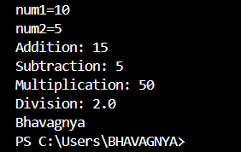

**NEGATIVE CASE:**

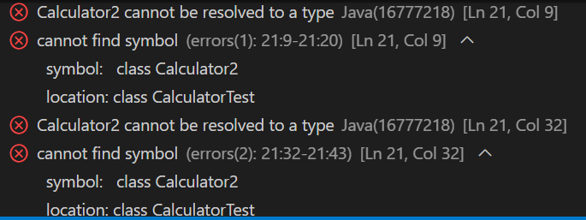

**ERROR TABLE:**

|  |  |  |
| --- | --- | --- |
| S.No | Errors | Rectification |
| 1) | Given wrong class name while object is created | Rectifying the given wrong class name |

**IMPORTANT POINTS**

**1. Multilevel Inheritance:**

* Multilevel inheritance occurs when a class is derived from another class, and then a third class is derived from the second class, forming a chain.

**2. Code Reusability:**

* The add() and subtract() methods are defined once in the Calculator class and can be reused by both the Calculator1 and Calculator2 classes without rewriting the code.
* The multiply() method is defined in Calculator1 and inherited by Calculator2
* The divide() method is added to the Calculator2 class.
* This shows how inheritance helps to reduce redundant code and increases reusability.

**3. Polymorphism (Use of Parent Class Reference):**

* The code demonstrates polymorphism (though not explicitly in the form of method overriding). Even though the object calc is of the class Calculator2, it can call methods from the base class (Calculator) and intermediate class (Calculator1) due to inheritance.

For example, calling calc.add(num1, num2) and calc.subtract(num1, num2) works because Calculator2 inherits from Calculator

**PROGRAM-2**

**AIM:** A vehicle rental company wants to develop a system that maintains information about different types of vehicles available for rent. The company rents out cars and bikes and they need a program to store details about each vehicle such as brand and speed

* Cars should have an additional property: number of doors
* Bike should have a property indicating whether they have gears or not
* The system should also include a function to display details about each vehicle and indicate when a vehicle is starting
* Every class should have a constructor

1. Which OOP concept is used in the above program? Explain why it is useful in this scenario.
2. If the company decides to add a new type of vehicle truck, how would you modify the program? Truck should include an additional property capacity(in tons). Create a showTruckDetails() method to display the truck’s capacity. Write a constructor for truck that initializes all properties.
3. Implement the truck class and update the main method to create a truck object, also create an object for car and bike subclassed. Finally display its details**.**

**CLASS DIAGRAM**:

|  |
| --- |
| Vehicle |
| + brand: String  + speed: int |
| + Vehicle(brand: String, speed: int)  + start(): void  + displayDetails(): void |

|  |
| --- |
| Car |
| +numberOfDoors: int |
| +Car(brand:String, speed: int, numberOfDoors: int)  + displayDetails(): void |

|  |
| --- |
| Bike |
| + hasGears: boolean |
| + Bike(brand: String, speed: int, hasGears: boolean) +displayDetails(): void |

## 

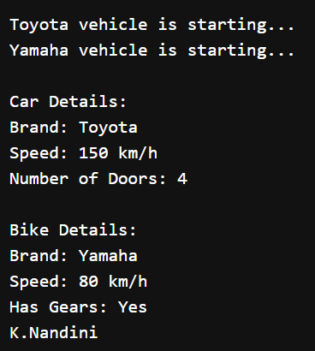

* 1. The OOP (Object-Oriented Programming) concepts used in the program are:
* **Inheritance**:
  1. Inheritance is a key concept here, as the Car, Bike, and Truck classes will all extend a common base class, Vehicle
  2. **Usefulness**: Inheritance allows common properties (like brand and speed) to be defined in the Vehicle class and inherited by the Car, Bike, and Truck classes. This avoids code duplication and allows new vehicle types to easily be added in the future without having to repeat common code.
* **Encapsulation**:
  1. Encapsulation is achieved by bundling the data (attributes such as brand, speed, etc.) and the behavior (methods like start(), displayDetails()) together into a single unit (the Vehicle class and its subclasses).
  2. **Usefulness**: It helps to hide internal details and protect the integrity of data by only exposing the necessary methods for interaction.
* **Polymorphism**:
  1. Polymorphism allows us to treat objects of different classes (Car, Bike, Truck) uniformly as objects of type Vehicle. Each subclass can override or extend methods like displayDetails() to provide its own behavior.
  2. **Usefulness**: This enables the program to handle different vehicle types generically while allowing specific behavior for each vehicle

**2 & 3)**

**CLASS DIAGRAM**:

|  |
| --- |
| Vehicle |
| + brand: String  + speed: int |
| + Vehicle(brand: String, speed: int)  + start(): void  + displayDetails(): void |

|  |
| --- |
| Car |
| +numberOfDoors: int |
| +Car(brand:String, speed: int, numberOfDoors: int)  + displayDetails(): void |

|  |
| --- |
| Bike |
| + hasGears: boolean |
| + Bike(brand: String, speed: int, hasGears: boolean) +displayDetails(): void |

|  |
| --- |
| Truck |
| + Capacity : double |
| +Truck(brand: String, speed: int, Capacity: double)  +showTruckDetails(): void |

